***Market Research***

**Frequency and trends**

* A 2019 survey found that most urban Indians prefer to consume food prepared in hotels and restaurants, but they primarily do so at home via delivery or takeout (48% preferring ordering in vs. 34% dining out and 18% takeout combined).
* Approximately 80% of Indians eat out at least once a month.
* A 2021 study revealed that 41% of respondents in a survey of 157 urban Indians reported eating out more than four times a month.
* Another study found that over 45 million Indians dined out at their favorite restaurants in 2021.
* Weekdays are seeing an increase in dining out due to busier lifestyles and less home-cooked food consumption.

**Demographics**

* The highest share of people eating out, around 40%, are in the age group of 21-30 years.
* Younger customers (18-39) are more likely to eat out or get takeout frequently, with 79% of those aged 18-29 eating out or ordering in 5 times or more per month according to HungerRush.
* Individuals aged 55 and above dine out significantly less, with 12% never eating out and 43% only doing so once or twice a month.
* Eating out frequency is significantly more prominent among males and self-employed individuals.
* Those with higher monthly income (over ₹15,000) also show a stronger preference for eating out.
* Preferences vary by city: Delhi was identified as the "Dining Capital of India" in 2021, accounting for 32% of total diners, followed by Bengaluru at 18%.

**Factors influencing choices**

* Convenience and Time-Saving: A major driver for dining out and food delivery is the convenience and time-saving it offers, particularly for working professionals, students, and families.
* Quality Cuisine and Ambiance: Hotel restaurants are known for high-quality cuisine, top-notch chefs, and sophisticated dining environments, offering a memorable gastronomic journey.
* Changing Consumer Preferences: Urbanization, rising middle-class income, and a desire for diverse culinary options contribute to the dining boom.
* Hygiene and Cleanliness: Consumers prioritize restaurants that maintain high standards of hygiene and cleanliness.
* Online Reviews and Recommendations: Online reviews and recommendations from family and friends significantly influence restaurant choices.
* Technology: The widespread use of smartphones and food delivery apps facilitates easy exploration of options, ordering, and delivery tracking.
* Sustainability: A growing number of consumers are concerned about the environmental impact of their food choices and seek out sustainable practices.
* Special Offers and Packages: Many hotels offer discounts and promotions to attract diners.

**Challenges faced by hotels**

* Talent Shortages and Skill Gaps: Attracting and retaining skilled hospitality staff is a significant challenge, exacerbated by high turnover rates.
* Evolving Guest Expectations: Guests now demand more personalized experiences, sustainability, and technological integration.
* Managing Regulations: Navigating a wide range of regulations, including health, hygiene, licensing, and environmental standards, can be complex and costly.
* Supply Chain Issues: Economic fluctuations and geopolitical events can disrupt supply chains, affecting the availability and cost of ingredients.
* Rising Competition: The hospitality market is increasingly competitive, with new players and evolving business models impacting established businesses.
* Seasonal Fluctuations: The hospitality industry is heavily influenced by seasonal trends, creating challenges in managing resources and profitability.
* Inventory Management: Maintaining accurate inventory, minimizing waste, and managing fluctuating food costs are critical for profitability.

**Economic impact**

* The Indian hospitality industry is a significant contributor to the economy, generating employment opportunities and foreign exchange revenue.
* In 2019, the industry accounted for 6.8% of India's GDP and employed 39 million people.
* The sector is projected to contribute a substantial amount to the country's GDP by 2047, [according to IBEF](https://www.ibef.org/industry/tourism-hospitality-india).
* Food and beverage (F&B) in hotels across India are becoming key revenue drivers, contributing between 35 and 50 percent to overall revenue.

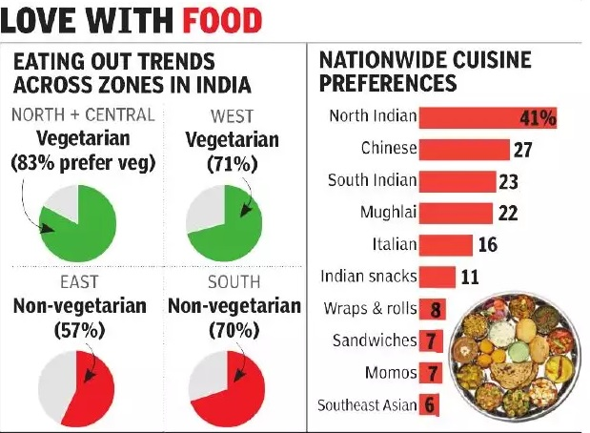

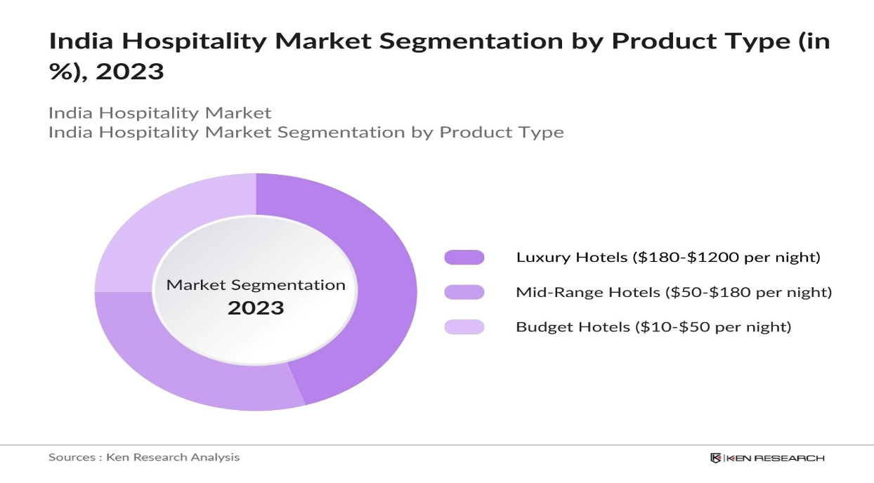

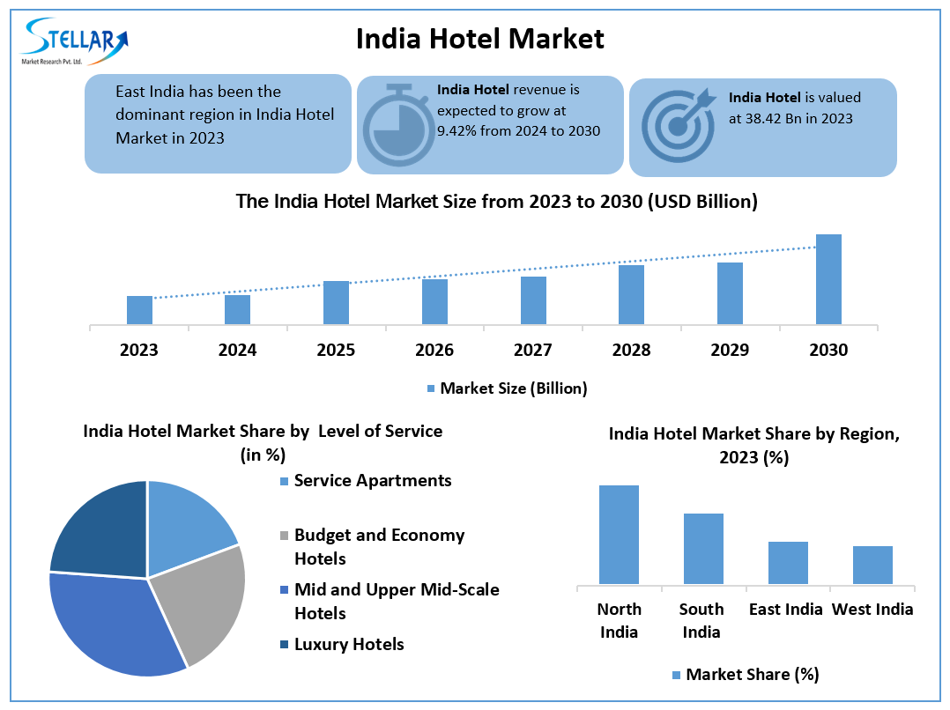

* **Experimentation and Variety:**

While some diners prefer sticking to their favorite restaurants, others are exploring new cuisines and dining experiences, including those offered by hotels.

* **City-Specific Preferences:**

In some cities, like Delhi, fast food and street food are popular, while in others, like Mumbai, there's a stronger preference for restaurants.

**References**

1. Times of India. 2019. “Urban Indians Prefer to Eat Hotel Food Sitting at Home, Study Finds.” December 6, 2019. <https://timesofindia.indiatimes.com/business/india-business/urban-indians-prefer-to-eat-hotel-food-sitting-at-home-study-finds/articleshow/72400238.cms>.
2. Khan, Wasiq, Shariq A. Ansari, and Md. Imran Siddiquei. 2021. “Determinants of Consumers’ Frequency of Eating Out: Implication for the Restaurant Business in India.” *International Journal of Services, Economics and Management* 12 (4): 388–403. <https://ideas.repec.org/a/ids/injsem/v12y2021i4p388-403.html>.
3. Restaurant India. 2024. “Eating Out Behaviour of Consumer Segments.” March 1, 2024. <https://www.restaurantindia.in/article/eating-out-behavior-of-consumer-segments.6130>.
4. Mint. 2016. “How India Eats Out.” July 22, 2016. <https://www.livemint.com/Consumer/DeU2aNxRI3U0unsxnjhy5L/Study-Quickservice-restaurants-top-dining-destination-for.html>.
5. Restaurant India. 2025. “8 Key Factors Driving India's Dining Out and Food Delivery Boom.” May 28, 2025. <https://www.restaurantindia.in/article/8-key-factors-driving-indias-dining-out-and-food-delivery-boom.11583>.
6. Restaurant India. 2025. “How People Choose Restaurants: Top 10 Factors.” July 2, 2025. <https://www.restaurantindia.in/article/how-people-choose-restaurants-top-10-factors.13133>.
7. India Brand Equity Foundation (IBEF). 2025. “Hospitality Sector, Tourism in India – IBEF.” April 15, 2025. <https://www.ibef.org/industry/tourism-hospitality-india>.
8. IGI Global. n.d. “Role of Tourism in Economic Growth of India.” Accessed July 14, 2025. <https://www.igi-global.com/chapter/role-of-tourism-in-economic-growth-of-india/147202>.
9. Today’s Traveller. 2024. “The Indian Hospitality Industry: A Crucial Force Behind Economic Growth.” October 26, 2024. <https://www.todaystraveller.net/indian-hospitality-industry-key-economic/>.
10. LinkedIn. 2025. “How Indian Hotels Can Maximize F&B Revenue with Smarter Strategies.” February 6, 2025. <https://www.linkedin.com/pulse/how-indian-hotels-can-maximize-fb-revenue-smarter-gknof>.
11. Hotelier India. 2019. “Indian Hotels Increasingly Bank on F&B to Contribute Almost 50% of Their Revenue Inflows.” March 14, 2019. <https://www.hotelierindia.com/fb/indian-hotels-increasingly-bank-on-fb-to-contribute-almost-50-of-their-revenue-inflows>.
12. Botshot. n.d. “12 Major Challenges in Hotel Industry & Its Solutions.” Accessed July 14, 2025. <https://botshot.ai/resources/blog/10-major-challenges-in-hotel-industry>.
13. Growth Engineering. 2025. “The 10 Biggest Challenges Facing the Hospitality Industry in 2025.” January 3, 2025. <https://www.growthengineering.co.uk/hospitality-challenges/>.
14. LinkedIn. 2024. “Unveiling the Indian Hotel Industry: Trends, Challenges, and Future Prospects.” July 25, 2024. <https://www.linkedin.com/pulse/unveiling-indian-hotel-industry-trends-challenges-future-prospects-sl58c>.

**Conclusion by market Research:**

* We can add additional features like:
  + 1. If customers dine out regularly, for streak maintaining any offers or rewards we can give.
    2. Owners if they maintain to get better ratings they will get some rewards from the company.
    3. Our main focus is on rural and semiurban areas to make them smart tech cities, where the reach of x,y,z competitors reach is not completely went.

**But as we know if we give streak maintaining gifts for customer then by ourselves it will be making them to dine out it will not be fine…**

**So…**

**Conclusion by market Research:**

* We can add additional features like:
* Owners if they maintain to get better ratings they will get some rewards from the company.
* Our main focus is on rural and semiurban areas to make them smart tech cities, where the reach of x,y,z competitors reach is not completely focused on.

***Literature Survey***

**Literature Review on EazyDiner: Market Performance and Strategic Insights (2025)**

**1. User & Engagement Metrics**

EazyDiner boasts over 3 million registered users with 750,000 monthly active diners and a high repeat usage rate of 80%, far exceeding industry averages (10–30%). This shows strong user engagement, particularly among urban premium diners.

**2. Restaurant Network & Partner Growth**

The platform partners with over 12,000 restaurants and is onboarding 1,000–1,500 per month. Its network is heavily focused on Tier-1 cities and premium dining. Expansion to Tier-2/3 cities is part of its FY24 goal to reach 30,000 partners.

**3. Financials & Profitability**

In 2023, EazyDiner raised ₹40 crore (~$4.8M) and reported YoY revenue growth of 211%, and an 849% jump in profit. The platform has reached profitability, driven by its PayEazy payments, commissions, and Prime memberships.

**4. Technology Strategy**

AI-driven recommendations, a 24/7 concierge, and LiveTable SaaS seat management improve user experience and restaurant efficiency. Its digital-first approach sets it apart from delivery-centric rivals.

**5. Banking & Ecosystem Partnerships**

EazyDiner has formed deep integrations with Google Search/Maps and partnered with banks like IndusInd, Axis, ICICI, and AmEx to provide users with discounts, exclusivememberships, and cashback offers. This boosts acquisition and retention.

**6. Market & Performance Milestones**

Peak days such as Mother’s Day 2024 showed record bookings (+198% dinner), ₹4,952 per-person average spend, and 92% occupancy. These demonstrate platform readiness during high-traffic events.

**7. Consumer Feedback & Challenges**

Users report issues with hidden convenience fees, failed PayEazy payments (33% failure with some cards), and inconsistent service at some restaurant partners. Despite these, satisfaction among premium users remains high.

**8. Retention Benchmarking**

EazyDiner’s 80% repeat usage rate dwarfs the food-tech industry's 10–30%. Retention is fueled by PayEazy incentives, Prime deals, and concierge service, indicating a loyal base.

**9. Competitive Analysis (Zomato & Swiggy Dineout)**

Zomato and Swiggy Dineout offer broader services and user bases (80M and 20M MAUs respectively). EazyDiner stays premium and niche-focused. Their challenge is expanding while preserving user experience and profitability.

**10. Future Outlook & Recommendations**

EazyDiner must improve its Tier-2/3 reach, fix payment/UX issues, and explore monetization via curated experiences. Global expansions (UAE) and more bank tie-ups can future-proof the platform against aggressive aggregator competition.

**Pros of EazyDiner**

**1. High Retention Rate**

* **80% repeat usage**—far above the 10–30% industry norm.
* Strong loyalty via **Prime memberships**, **PayEazy** benefits, and **exclusive bank offers**.

**2. Premium Market Focus**

* Targets **high-income urban diners**, a more stable and profitable segment.
* Focuses on **premium restaurants, 5-star hotels**, and curated events instead of discount-hunting casual diners.

**3. Advanced Technology Integration**

* Uses **AI-driven recommendations**, 24×7 **concierge services**, and **LiveTable SaaS** for restaurant partners.
* In-app payment via **PayEazy** with cashback and rewards encourages app stickiness.

**4. Banking & Ecosystem Partnerships**

* Deep tie-ups with **Axis, ICICI, IndusInd, AmEx**, etc.
* **Google Search/Maps** and **TripAdvisor** integration allows seamless bookings from outside the app.

**5. Strong Monetization Strategy**

* Generates revenue via:
  + Prime subscriptions
  + Restaurant commissions
  + PayEazy transaction partnerships
* Became **profitable in FY23**—a rare feat in Indian food-tech.

**6. Scalable Model**

* Onboarding **1,000–1,500 restaurants per month**.
* Plans to expand to **30,000 partners** and into **Tier-2/3 cities** and **Gulf countries**.

**❌ Cons of EazyDiner**

**1. Limited Reach Beyond Metro Cities**

* Still heavily focused on **Delhi, Mumbai, Bangalore, Hyderabad, and Dubai**.
* **Tier-2/3 presence is minimal** compared to Zomato and Swiggy.

**2. Payment Failures & UX Bugs**

* **PayEazy** has reported **33% failure rate** for some credit cards (especially Axis, AmEx).
* Some UX issues like double bookings, delays in cashback refunds, etc.

**3. Hidden Convenience Fees**

* Despite offering discounts, **users report ₹25–₹45 convenience charges** that feel hidden or unjustified.
* Can hurt trust and satisfaction over time.

**4. Customer Service Variability**

* Mixed reviews on the **concierge service** and **restaurant-level service** execution.
* Complaints about **delayed seating**, missing reservations, or lack of awareness by the restaurant staff.

**5. Strong Competition**

* Faces stiff competition from:
  + **Zomato** (80M MAU) with in-app dineout, delivery, and reviews
  + **Swiggy Dineout** (20M diners), which focuses on buffet deals and discounts.
* These players have deeper reach and funding.

**6. Narrower Target Segment**

* Focus on **premium diners only** limits user base growth.
* Price-sensitive casual diners may find better value on other platforms.

**References – EazyDiner Literature Review**

1. Jadhav, R., Titus, A., Babu, M. M., & Chinnaiyan, R. (2023). *Evaluation of Consumer Behaviour Regarding Food Delivery Applications in India*. arXiv. <https://arxiv.org/abs/2401.14409>
2. Madani, R., & Alshraideh, M. (2021). *Predicting Consumer Purchasing Decision in The Online Food Delivery Industry*. arXiv. <https://arxiv.org/abs/2110.00502>
3. Analytics India Magazine. (2019). *EazyDiner Bets Big On Machine Learning To Drive More Users On Its Platform*. <https://analyticsindiamag.com/deep-tech/eazydiner-bets-big-on-machine-learning-to-drive-more-users-on-its-platform>
4. CNBC TV18. (2023). *Eating Out Made Easy: EazyDiner Bets Big on Artificial Intelligence to Grow*. <https://www.cnbctv18.com/startup/eating-out-made-easy-eazydiner-bets-big-on-artificial-intelligence-to-grow-4124271.htm>
5. Shah, K. (2021). *Case Study: How EazyDiner Completed Onboarding and Went Live in Days*. Medium. <https://kinjal-shah.medium.com/case-study-how-eazydiner-indias-top-restaurant-table-booking-app-completed-onboarding-and-went-41d2ecf255c>5
6. Forbes India. (2016). *Eating Out? Reserve Your Table with EazyDiner*. <https://www.forbesindia.com/article/work-in-progress/eating-out-reserve-your-table-with-eazydiner/42875/1>
7. YourStory. (2019). How EazyDiner Expanded Using TripAdvisor and Google Integration. <https://yourstory.com>
8. India Retailing. (2018). How Reservation Apps Are Changing the Dining Landscape. <https://www.indiaretailing.com/2018/01/10/reservation-apps-changing-dining-landscape>
9. TechCircle. (2015). Restaurant Booking Will Evolve Like Online Travel: EazyDiner Founders. <https://www.techcircle.in/2015/04/24/restaurant-booking-is-likely-to-evolve-like-online-travel-say-eazydiner-founders>
10. Reddit. (2023). EazyDiner Experience: Delayed Service and Service Charge Issues. <https://www.reddit.com/r/thane/comments/1f10t5l>
11. Reddit. (2024). EazyDiner & IndusInd Card Combo: Is it Worth It? <https://www.reddit.com/r/CreditCardsIndia/comments/1g2xbk5>